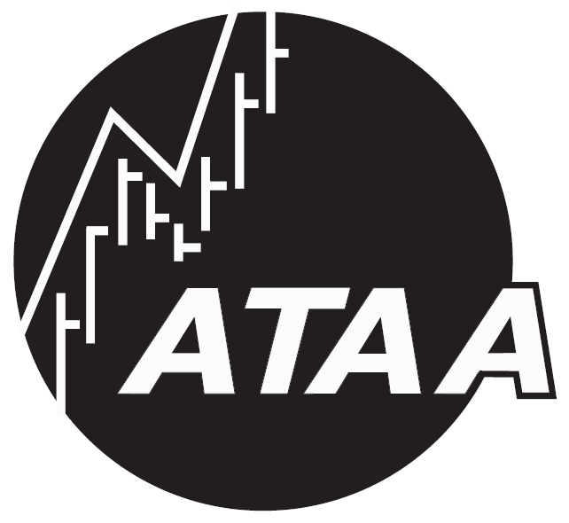
Australian Technical Analysts Association
Melbourne Chapter

Visitor & New Member
Information Sheet

A special welcome to Visitors and New Members.
About the ATAA:
- An independent, not-for-profit organisation, formed in 1990.
- Provides technical analysis resources, education and networking opportunities.
- Complements all levels of investors and traders.
- Is run on a voluntary basis by members, for members.
ATAA Member Services features include:
- great monthly meetings  - free video library  - member discounts  - INO TV web access | - networking opportunities to share ideas  - extensive website resources  - informative guest speakers at meetings  - annual conference
Some information about the Melbourne Chapter:
- This is one of nine chapters around Australia.
- We run a “Visitors / New Members Huddle” get-together,
to answer your questions and help you feel at home.
- Our member base includes: learners and part-time traders/investors who have a “regular” day job; many SMSF investors; full-time traders; professional traders.
- Monthly meetings (about 100 people +/- 30):
- Generally second Thursday of the month at the Shell Theatrette,
corner Spring and Flinders Streets Melbourne.
- Networking opportunities (and drinks, nibbles) from 5pm, and
the meeting presentations from 5:30pm to 7:30pm.
- Either one or two guest speakers presenting on relevant topics
for most of the duration of the 2-hour meeting.
- Followed by dinner (optional) at a local restaurant for a reasonable cost
(currently at the Swiss Club — one wine, main and dessert — $28);
booking must be made and paid on the night at the meeting Dinner Table.
More information is included on the blue flyer “Realise your market edge”.

If you have any questions,
please feel free to ask one of our Committee members.
Robert Brain
Vice-President, ATAA Melbourne Chapter
Visit us on the web: www.ataa.com.au

